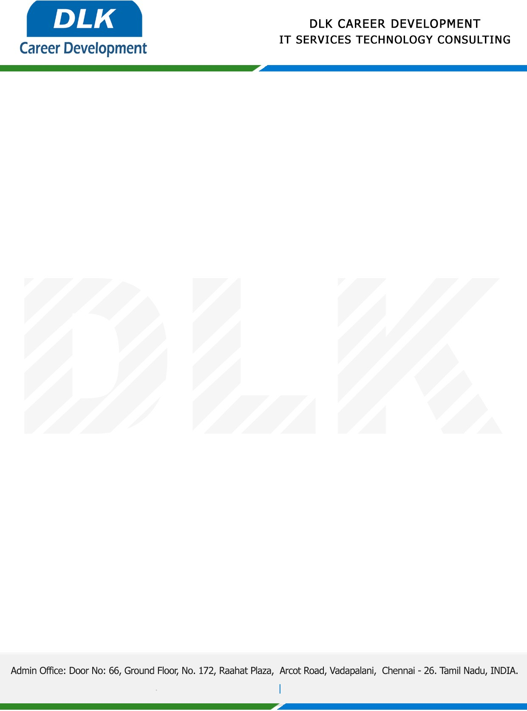

**Date: 23/January/ 2023**

**SUB: INTERNSHIP COMPLETION LETTER**

This is to certify that **MS THIRUTHIKA A (REG NO:122003460)** of **BCOM -Corporate Secretaryship,** final year student at **Tagore College of Arts and Science, Chennai** has Successfully Completed the Internship Work under the domain of “**Digital Marketing “** in our organization during the Period **(19th December 2022** to **23rd January 2023).**

We appreciate your interest in **DLK CAREER DEVELOPMENT**

**“Best Wishes for Your Future Endeavors “**

For **DLK CAREER DEVELOPMENT**

**HR Manager**

**VELMURUGAN J**